Market Questionnaire
Allergies and Allergic Diseases

Opportunities in your country:
a first overview of key factors


Table of content

General Allergy Information 3
Questionnaire Part 1: General Questions 4
Questionnaire Part 2: Allergen Immunotherapy (AIT) 6
Questionnaire Part 3: Regulatory Issues 7
Appendix 10
1. Useful Abbreviations and Definitions 10
2. Allergopharma Product Portfolio 11
3. Allergopharma Distributors 13

General Allergy Information

Allergy is a lifestyle disease. With increasing civilization, more and more people are suffering from the symptoms of respiratory allergies. It is estimated that 20 to 30 % of the world's population in industrialized countries suffer from allergies. On average, each person reacts to two or three different allergens.

Today, allergens are divided into eight main groups: House dust mites, pollen and plant allergens, epithelia (cat, dog, horse, etc.), hymenopteran venom, mold and yeast spores, food allergens, chemical or medical allergens and contact allergens.

Allergopharma is an international company with a fully integrated global network. For more than 50 years, we have been conducting research in close collaboration with physicians and scientists and developing solutions for allergy treatment - from diagnostics to allergen immunotherapy (AIT). We are the first company to have published data on the presence of almost all major, intermediate and minor allergens in the preparations for allergy diagnostics and AIT for house dust mite, grass, tree and mugwort allergy sufferers. With our many years of expertise, scientific excellence and entrepreneurial responsibility, we are getting closer step by step to our great vision: to cure allergies. You can find our complete portfolio at the end of this document.

In contrast to symptomatic treatments, the benefits of AIT are long-lasting. It is the most effective therapy for pollen, dust and animal epithelial allergies and can also help asthmatics. The WHO considers AIT to be the only effective treatment for eliminating the cause of allergic diseases.

Questionnaire Part 1: General Questions

1.1 General information about your country and health care system

Number of inhabitants:
Percentage of people with statutory health insurance:
Percentage of people with private health insurance:
Health expenses per capita:
Other key data:

Sources:

1.2 General information about allergies

Allergy prevalence (in %): | Year:
Most frequent allergen sources responsible for sensitizations in allergic patients: | Pollen:  -  -  -  Mites:  -  -  -  Epithelia:  -  -  -  Molds:  -  -  -  Food:  -  -  -
Sources:

1.3 General information about allergy diagnosis and therapy

Type of physician who carries out the allergy diagnosis and therapy: | ☐ General practitioners  ☐ Allergologists  ☐ Dermatologists  ☐ ENTs (ear, nose, and throat)  ☐ Pneumologists  ☐ Pediatricians  ☐ Specialists  ☐ Hospital  ☐ Others:
Diagnostics for the detection of allergies: | In vivo  ☐ Skin prick test  ☐ Provocation test  (bronchial, conjunctival or nasal)  In vitro  ☐ Serological IgE Measurement  Others:
Therapy for the treatment of allergies: | Symptomatic treatment  ☐ Antihistamines  ☐ Other:  Causal treatment  ☐ Allergen immunotherapy (AIT)  ☐ Others:
Physician’s prescription required to receive an AIT product: | ☐ Yes  ☐ No
Sources:

Questionnaire Part 2: Allergen Immunotherapy (AIT)

2.1 General information about AIT

Type of AIT available:  (please include market shares if available) | Subcutaneous immunotherapy (SCIT)  ☐ Aqueous preparations (aqueous protein solutions)  ☐ Depot preparations  ☐ Allergoid (chemical modified protein adsorbed to an adjuvant)  ☐ Bulk (self-dispended through physicians)  Sublingual immunotherapy (SLIT)  ☐ Liquids  ☐ Tablets  Others:
Total AIT market size: | Units: Year:  Value: Currency:
Market share SCIT vs. SLIT: | SCIT: % SLIT: %
AIT market players:  (please include market shares if available) | ☐ ALK  ☐ Allergy Therapeutics / Bencard Allergy  ☐ HAL Allergy  ☐ HollisterStier Allergy  ☐ Inmunotek  ☐ LETI Pharma  ☐ Lofarma  ☐ Roxall  ☐ Stallergenes Greer  ☐ Others:
Sources:

Questionnaire Part 3: Regulatory Issues

At Allergopharma, we extract allergen proteins from natural sources and incorporate them into a biopharmaceutical product.

In our export business, we are confronted with regulatory requirements that vary from country to country. While in some countries our products are handled with little or no requirements, other countries require extensive dossiers, and the regulatory issues are more complex.

In this part of the questionnaire, we would like to know what the situation is like in your country.

3.1 General information about the regulation of allergen immunotherapy (AIT) products

Name of authority responsible for AIT products:
Further key parties responsible for AIT products:
National guidelines/regulations that should be followed:
Please provide a document/link where they can be found.
National marketing authorization required for AIT products: | ☐ Yes please go on to question 3.1.1  ☐ No please go on to question 3.1.2
Sources:

3.1.1 General information about marketing authorization

For a national authorization,  a marketing authorization is required in the country of origin of the product: | ☐ Yes  ☐ No
Authorization in an EU country (e.g. Germany, Poland, Switzerland) is recognized when applying for a national marketing authorization: | ☐ Yes  ☐ No
Requirements for marketing authorization: | ☐ EU-CTD (Clinical Trials Directive)  ☐ National requirements – please specify:
Estimated duration of a marketing authorization procedure:
Batch release by a national competent authority (NCA) required: | ☐ Yes. Please indicate authority:  ☐ No
Sources:

3.1.2 General information about importing an AIT product without marketing authorization

On what other basis can an AIT product be marketed in your country? | ☐ Special import license  ☐ Named patient program (NPP)  ☐ Others:
If an import license is possible, the conditions for issuing the license are:
Existing import restrictions for medicinal products or products on named patient basis: | ☐ Yes – please indicate restrictions:  ☐ No
Existing restrictions for foreign pharmaceutical companies: | ☐ Yes – please indicate restrictions:  ☐ No
Sources:

3.2 General information about reimbursement of AIT products

Explanation of the procedure for determining the price of an AIT product:
Stakeholders who determine the price of an AIT product: | ☐ Authority – please indicate:  ☐ Insurance companies  ☐ Others – please indicate:
AIT products are reimbursed by the statutory health insurances: | ☐ Yes – how much:  ☐ No
AIT products are reimbursed by the private health insurances: | ☐ Yes – how much:  ☐ No
Requirements for the reimbursement of AIT products:
Sources:

THANK YOU VERY MUCH FOR YOUR EFFORT AND TIME!

Please send the completed questionnaire to:
International@allergopharma.com

Should you have any questions, do not hesitate to contact us.
We will come back to you as soon as possible.

Appendix

- Useful Abbreviations and Definitions

AR - Allergic rhinitis
Allergic rhinitis is often the first stage in the development of asthma. The so called “allergic march” starts with symptoms like a blocked nose, watery eyes and then continues its way downwards the human body into the lungs causing asthma.

Antihistamine Treatment
Antihistamines suppress the histamine-induced wheal (swelling) and vasodilation (flare) response by blocking the binding of histamine to its receptors on nerves, vascular smooth muscle, glandular cells, endothelium, and mast cells. Itching and sneezing are just suppressed by antihistamine, blocking H1-receptors on nasal sensory nerves. Antihistamines are commonly used for a relief of allergies. Their effect disappears shortly after ending the treatment.

AIT - Allergen immunotherapy
Allergen immunotherapy (also termed hyposensitization therapy, immunologic desensitization, hyposensibilization, or allergen-specific immunotherapy) is a form of immunotherapy for allergic disorders in which the patient is vaccinated with increasingly larger doses of an allergen (substances to which they are allergic) with the aim of inducing immunologic tolerance. Allergen immunotherapy is the only treatment strategy which treats the underlying cause of the allergic disorder. It is a highly cost-effective treatment strategy which results in an improved quality of life and a reduction in allergic- and allergen-related asthma, as well as a reduction in days off school/work

SLIT - Sublingual immunotherapy.
A method within AIT. Therapy is administered under the tongue (sublingually).

SCIT - Subcutaneous immunotherapy
A method within AIT. Therapy is administered by injections under the skin (subcutaneous).
Subcutaneous injection immunotherapy has been shown to be highly efficacious treatment for allergic disease.

- Allergopharma Product Portfolio

Products for the diagnosis of allergic diseases:
Skin prick test solutions and provocation test solutions

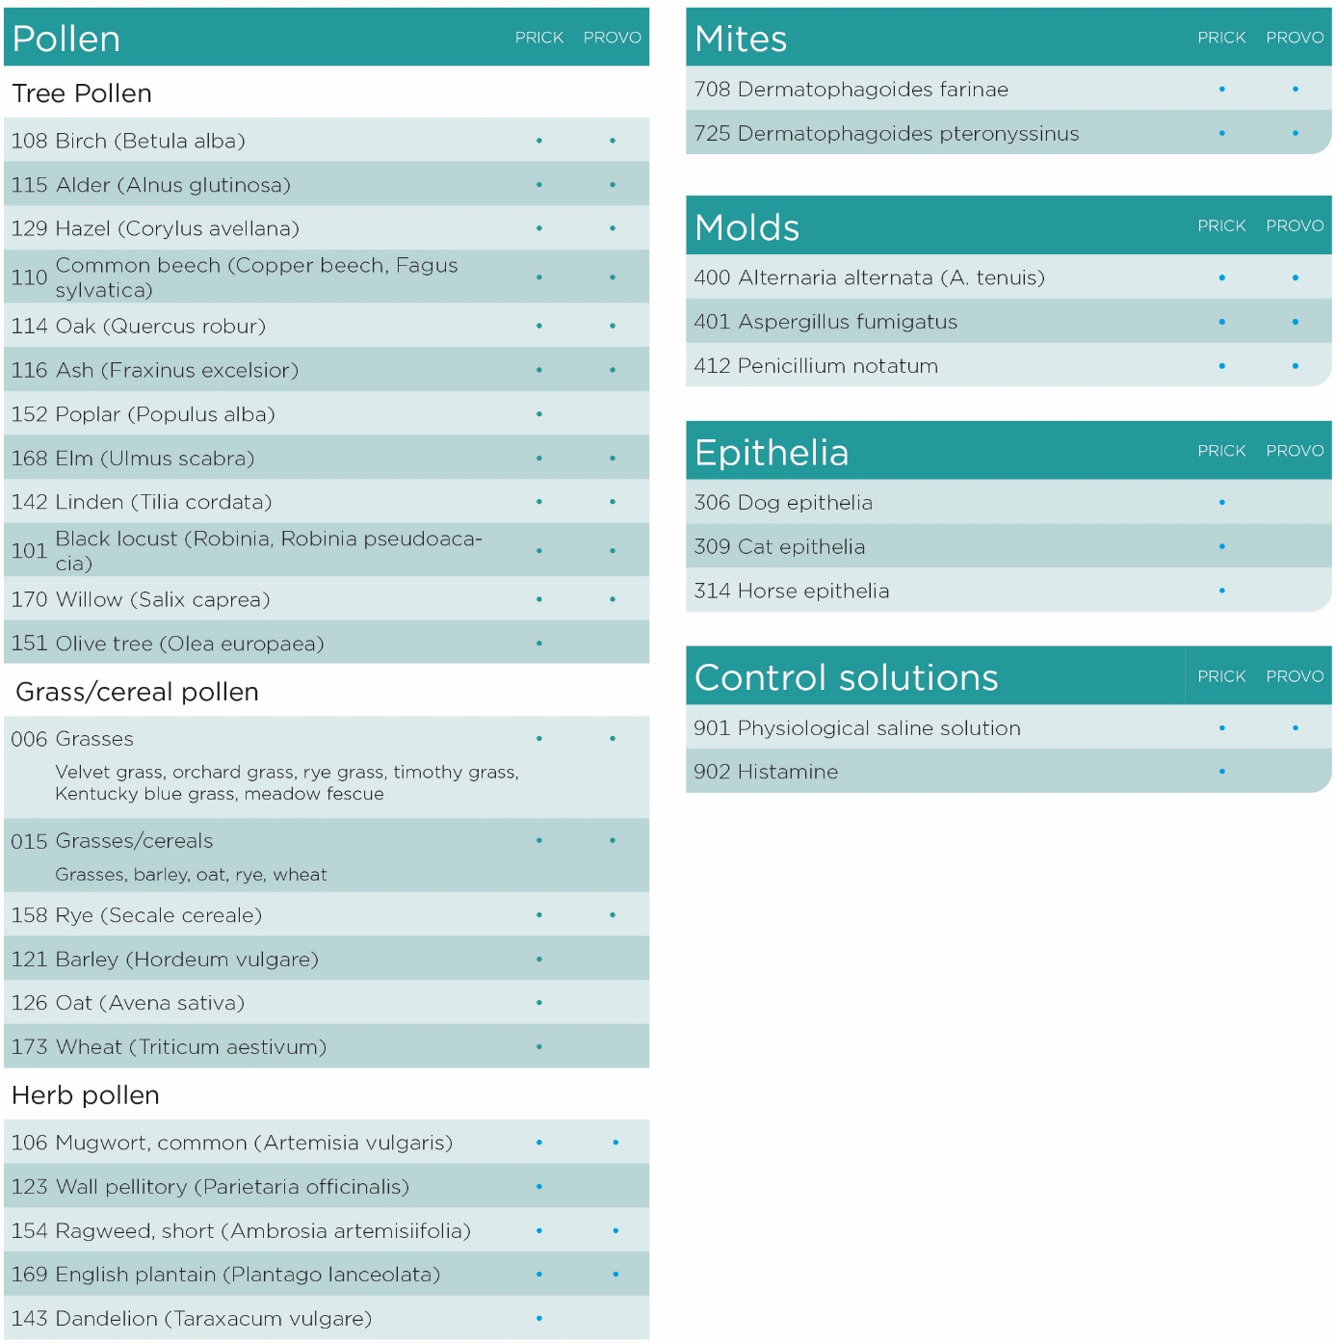

Products for the therapy of allergic diseases
Pollen allergies

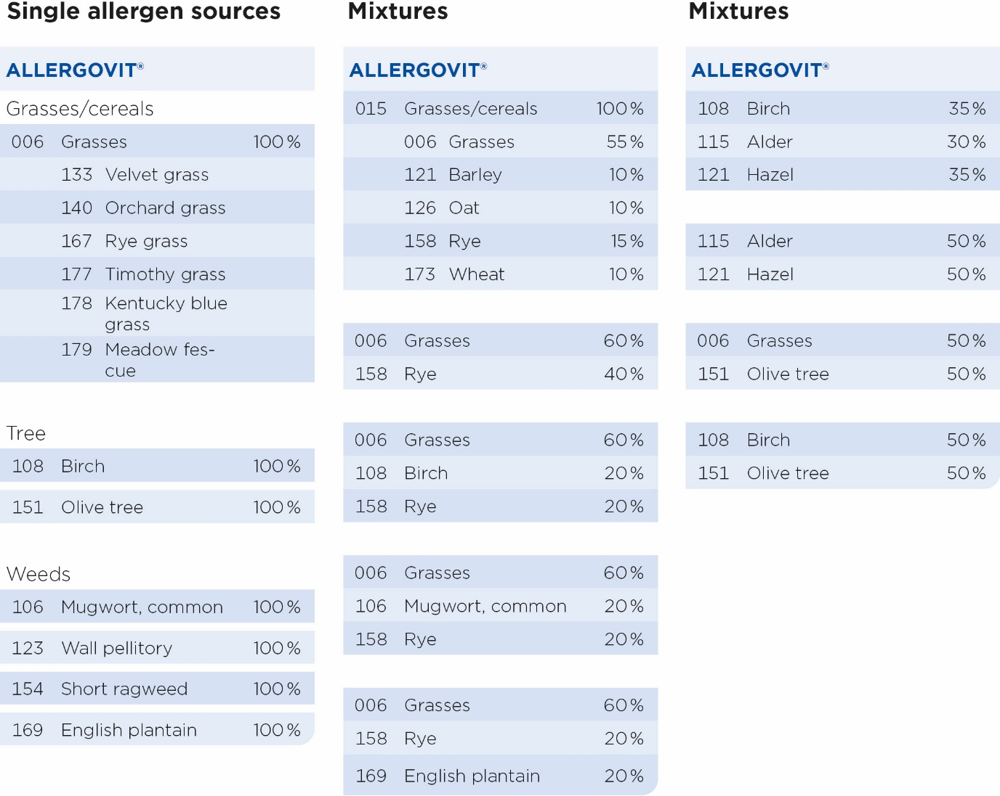

House dust mite allergies
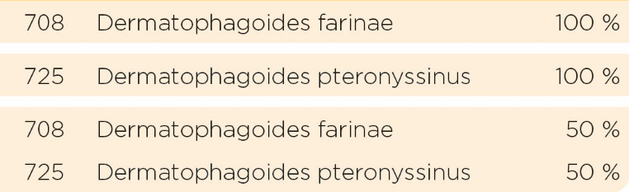

Molds
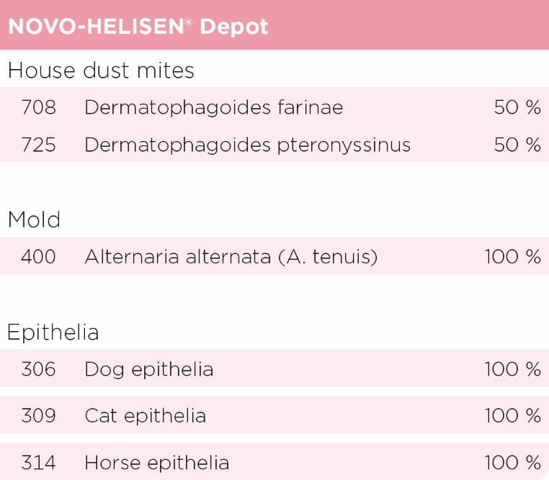

Epithelia

- Allergopharma Distributors

